Steps To create Auto Scaling Launch Template
Step 1: Click on the All Services on AWS Dashboard
Step 2: Click on the EC2(Elastic Cloud Computing).
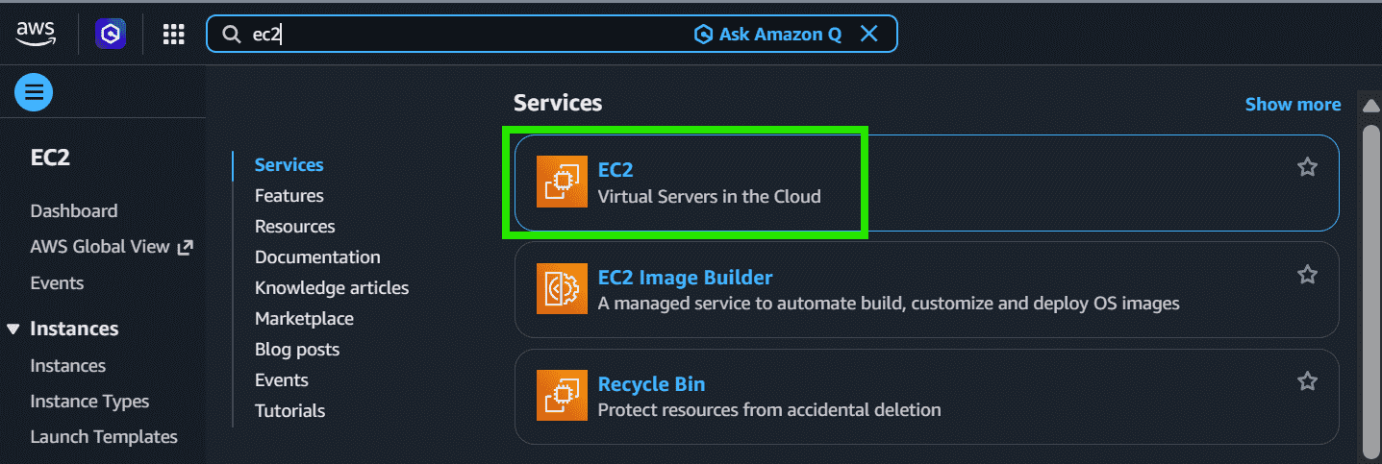
Step 3: Scroll Down and click on the Launch Templates and click on the Create launch template
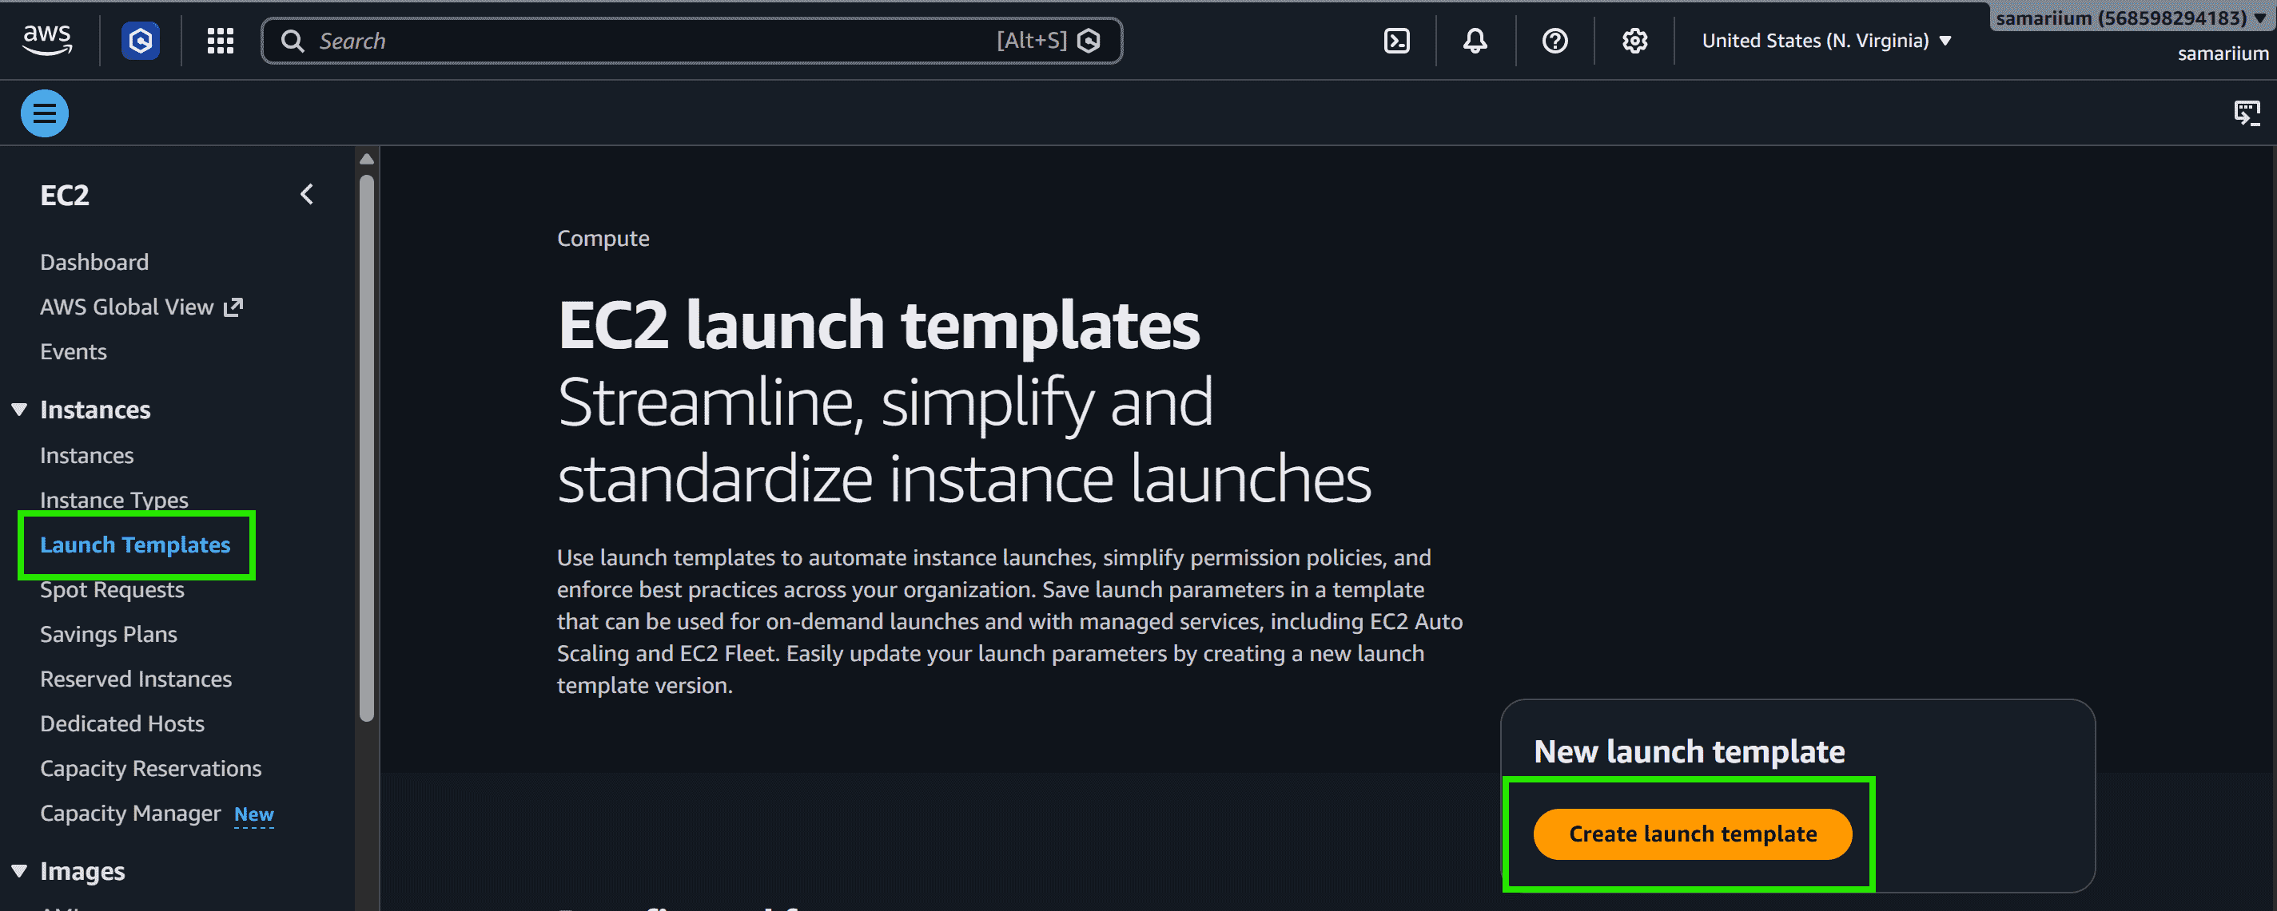
Step 4: Type the Template name.
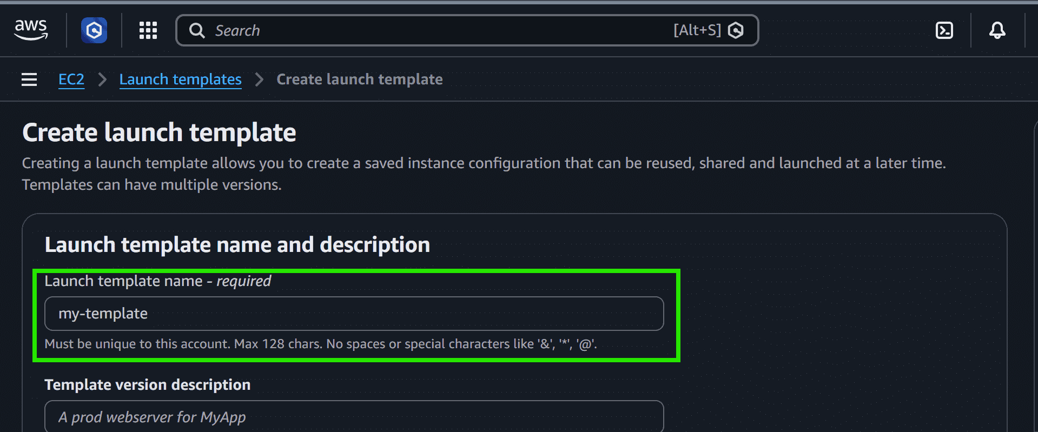
Step 5: Select the Amazon Machine Image.
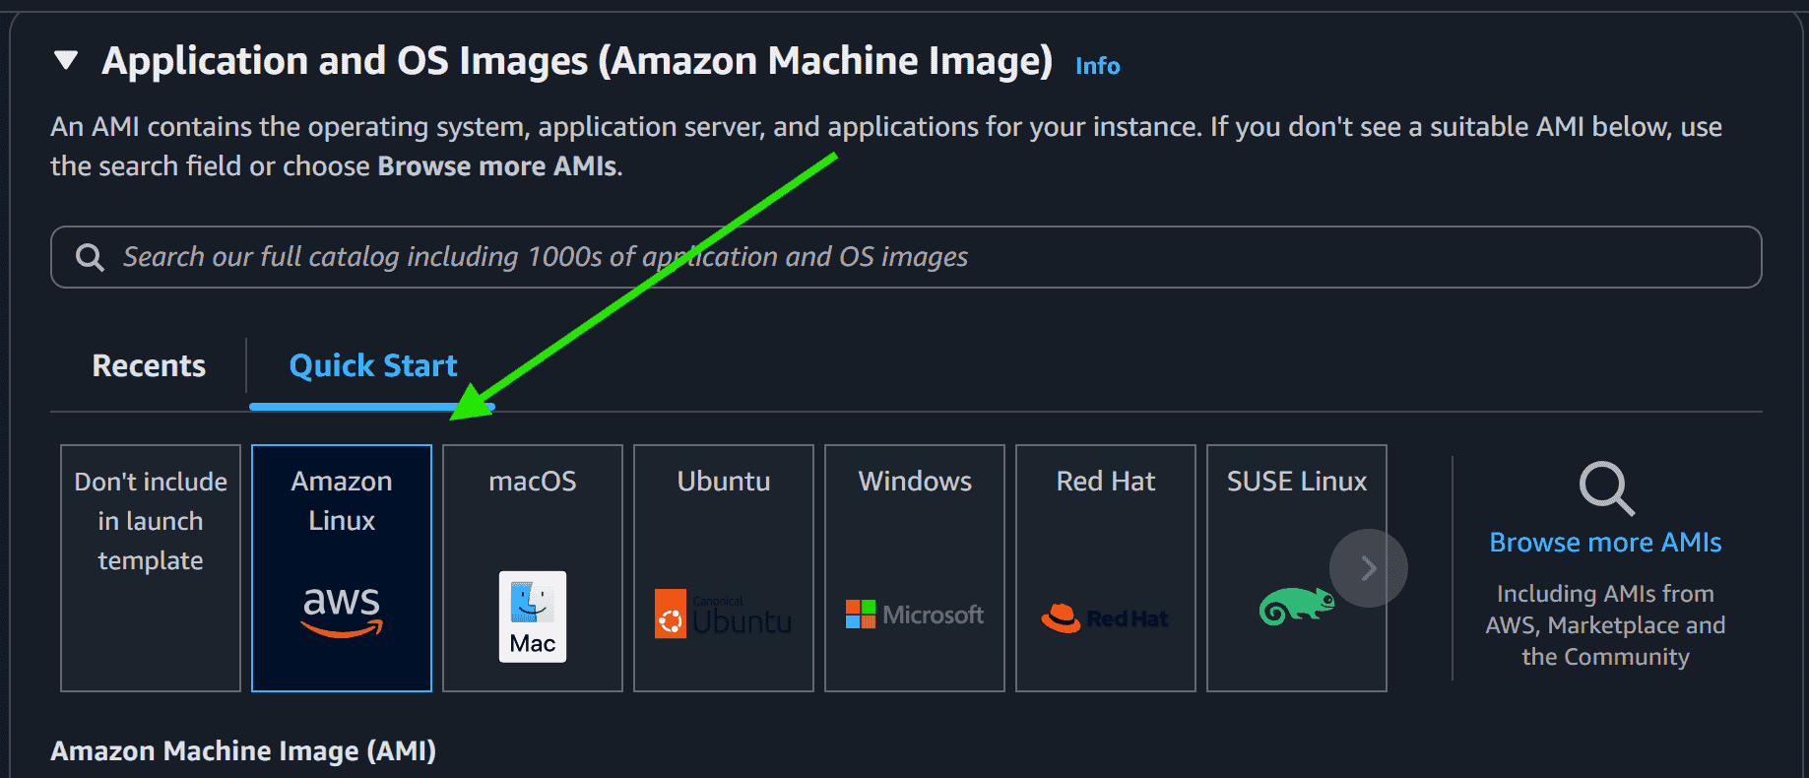
Step 6: Select the Instance Type and Key pair.
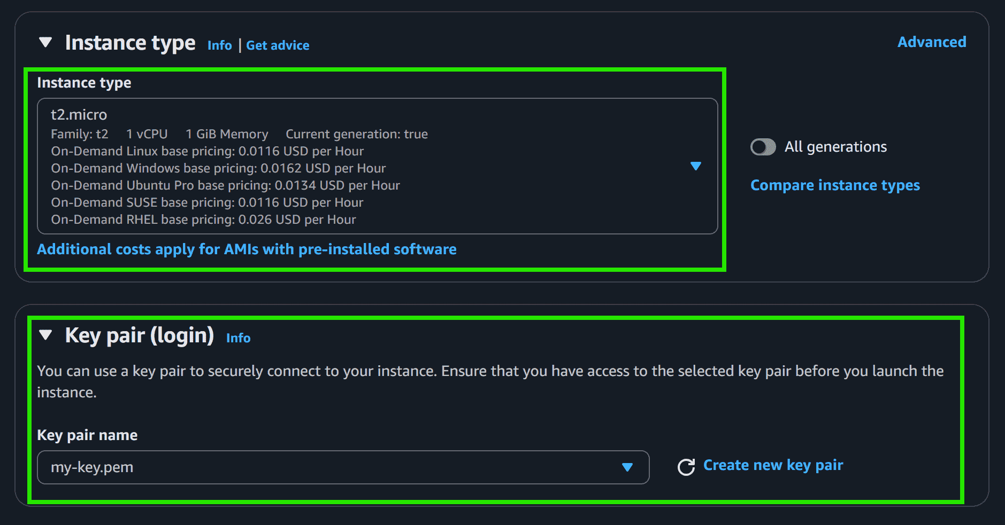
Step 7: Select the Security Group or Create the new one.
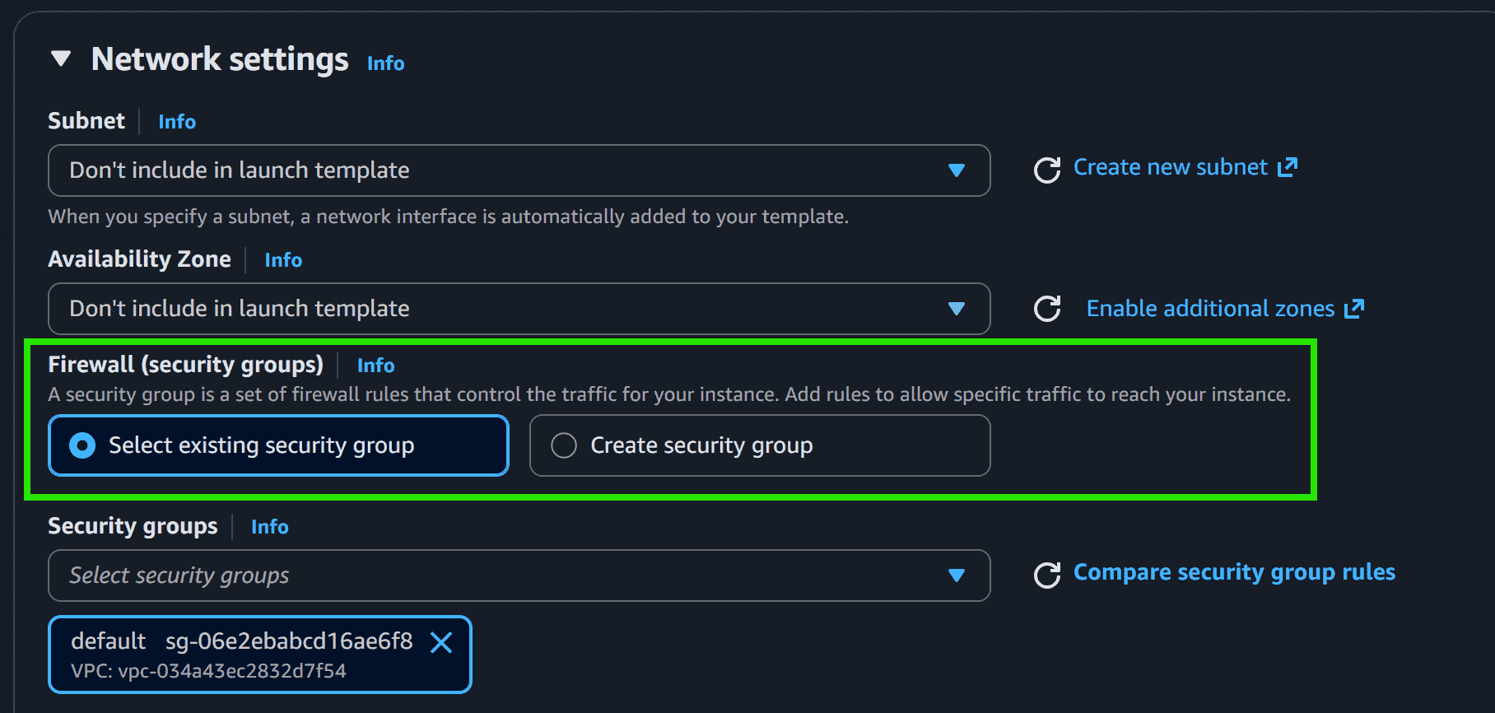
Step 8: Click on the Create Launch Template.
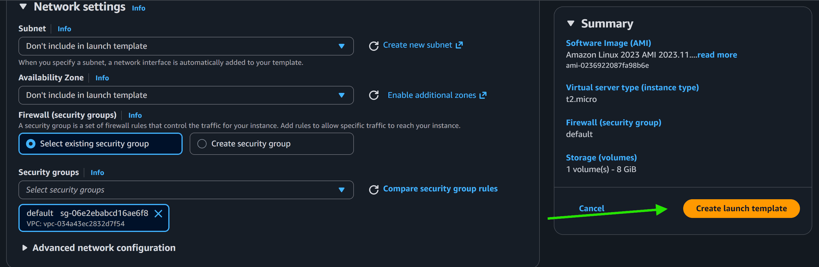
Step 9: Now you can see the template is created. Now, scroll down and click on the Auto Scaling Groups.
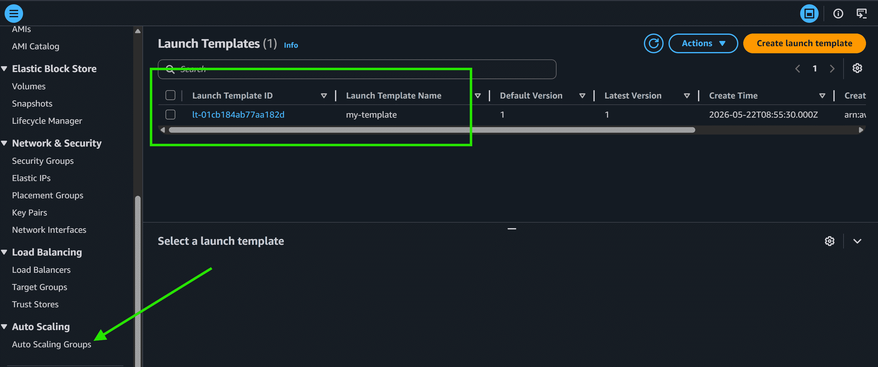
Create An Auto Scaling Group Using a Launch Template
Step 1: Click on the Create Auto Scaling group.
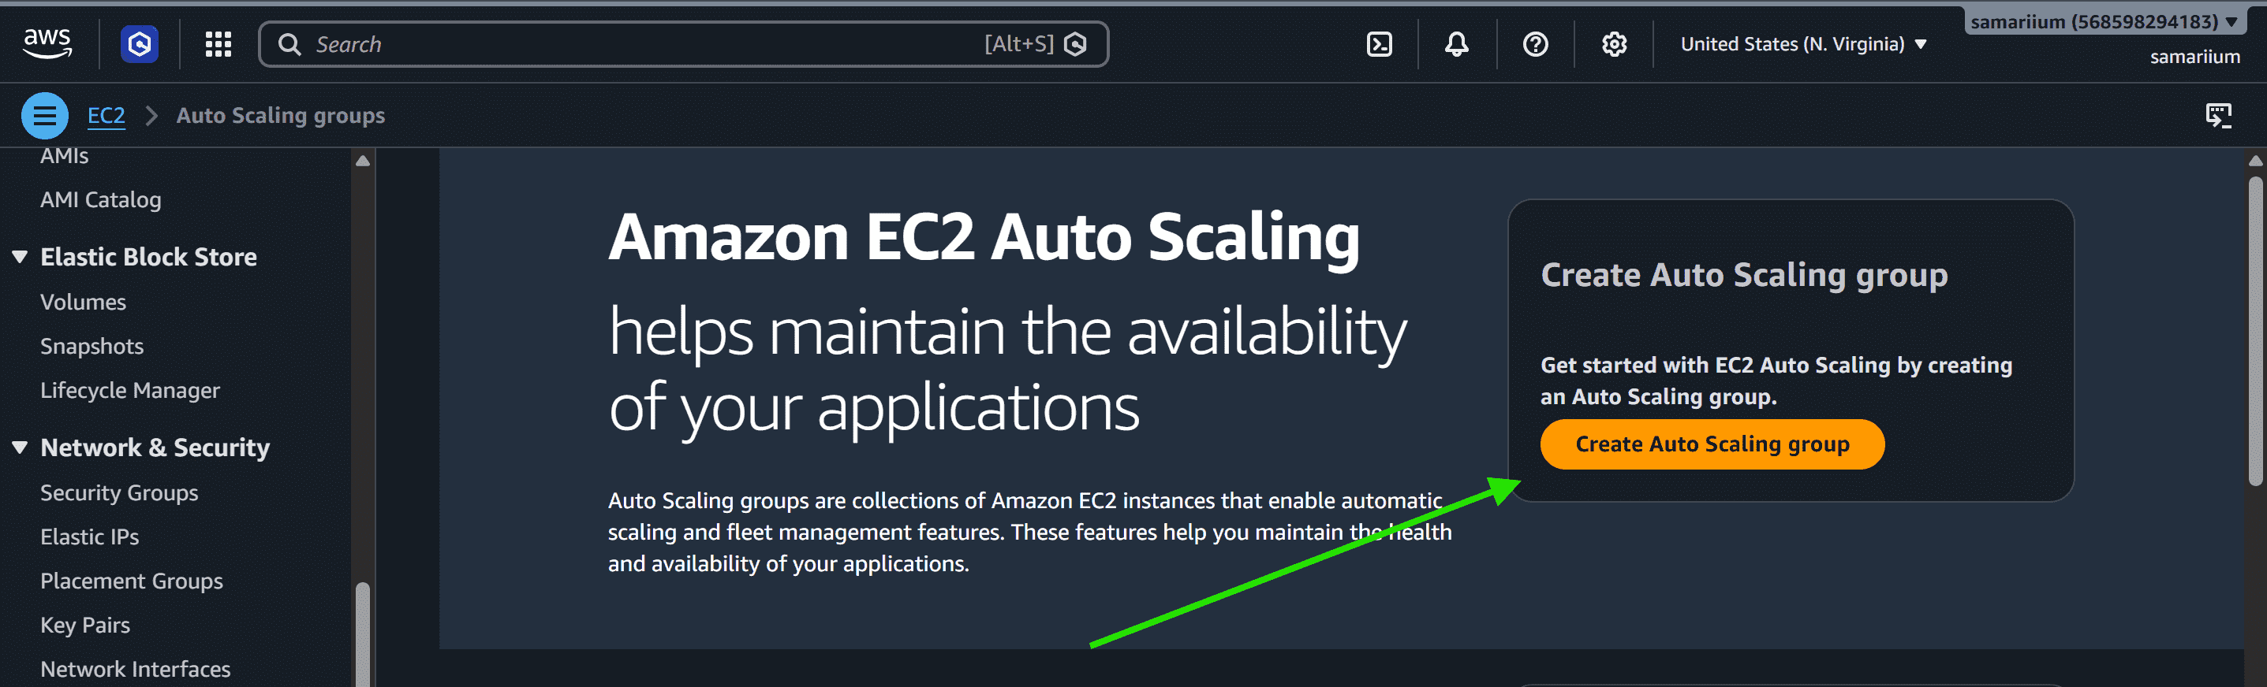
Step 2: Type the Auto Scaling group name.
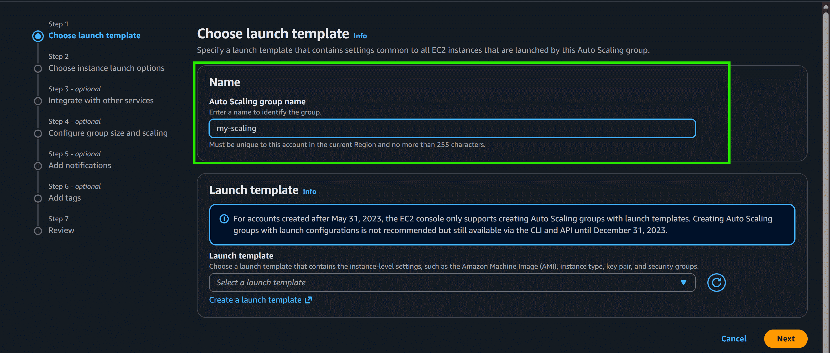
Step 3: Select your Template.
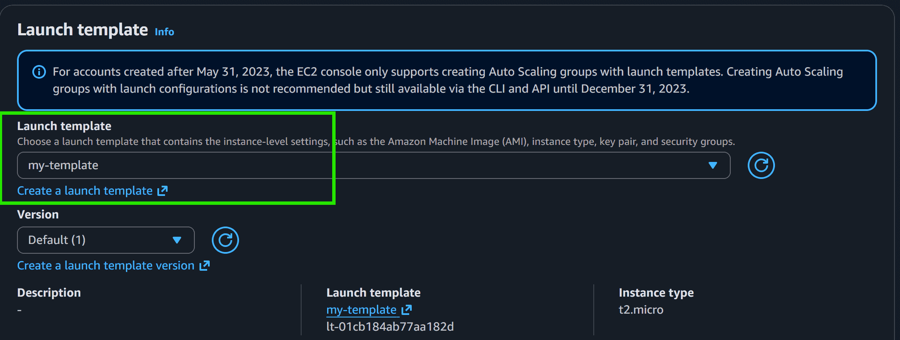
Step 4: Select the VPC or go with the default VPC and also select the Availability zone.
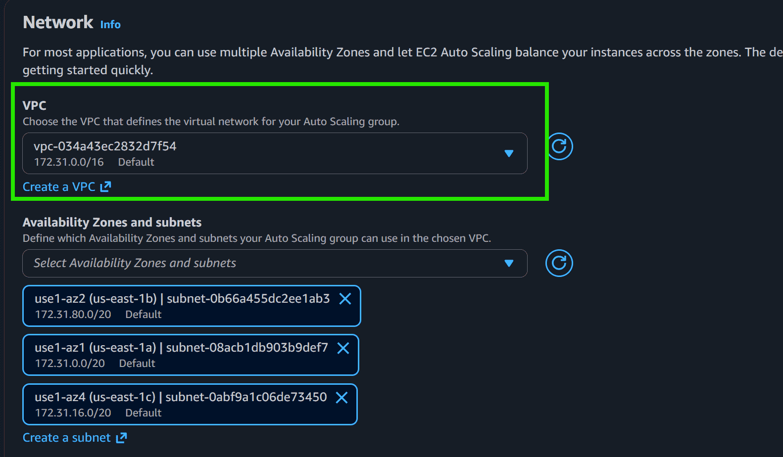
Step 5: Skip Integrate with other services
Step 6: Configure the Group size and Scaling policies.
Select as per your requirement:
- Desired: 4
- Minimum: 4
- Maximum: 8
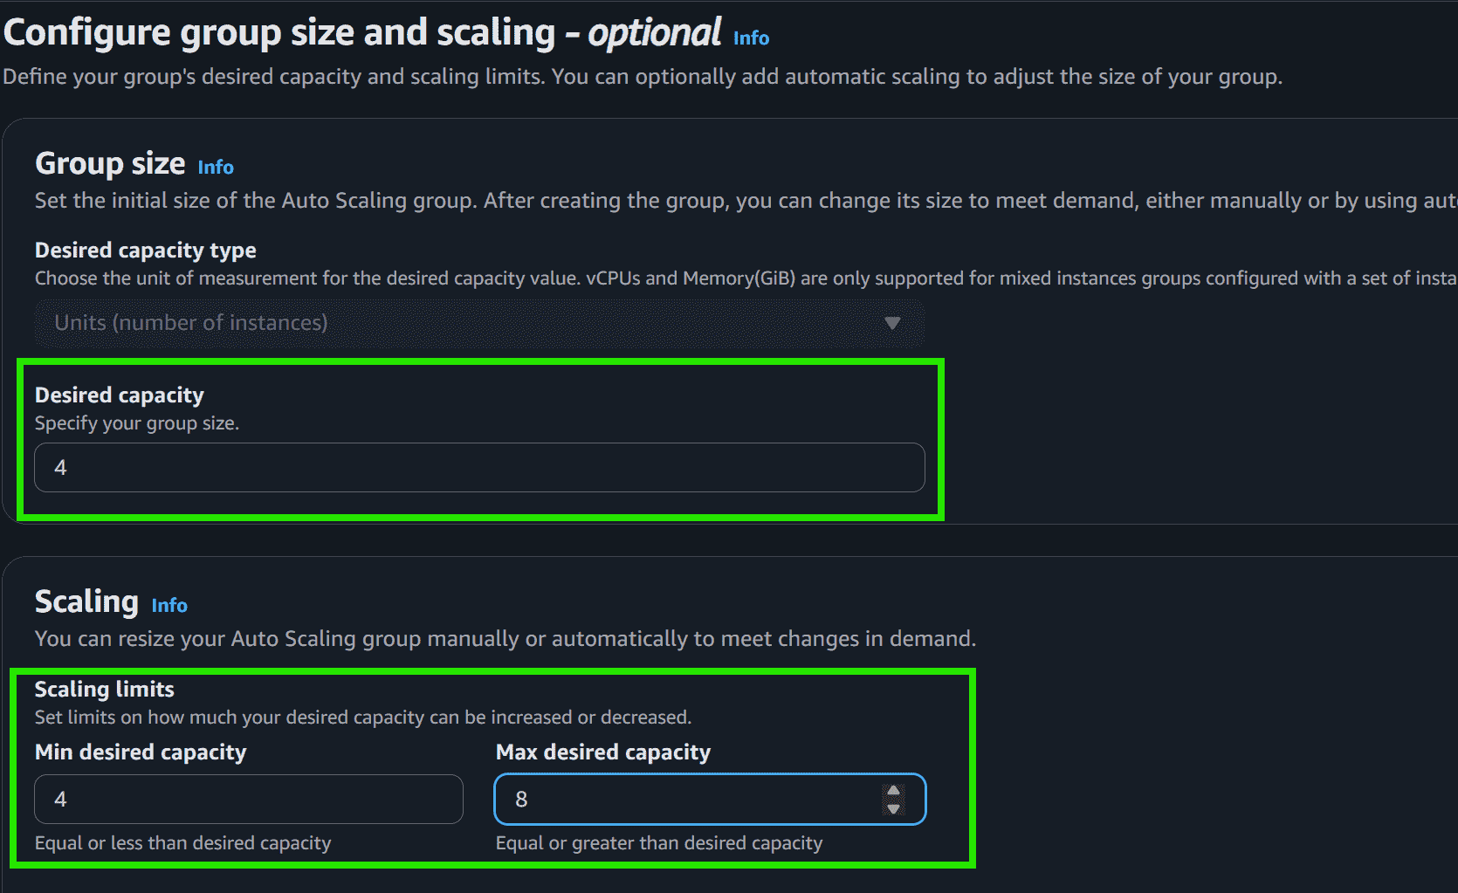
Step 7: Select the Target tracking scaling policy.
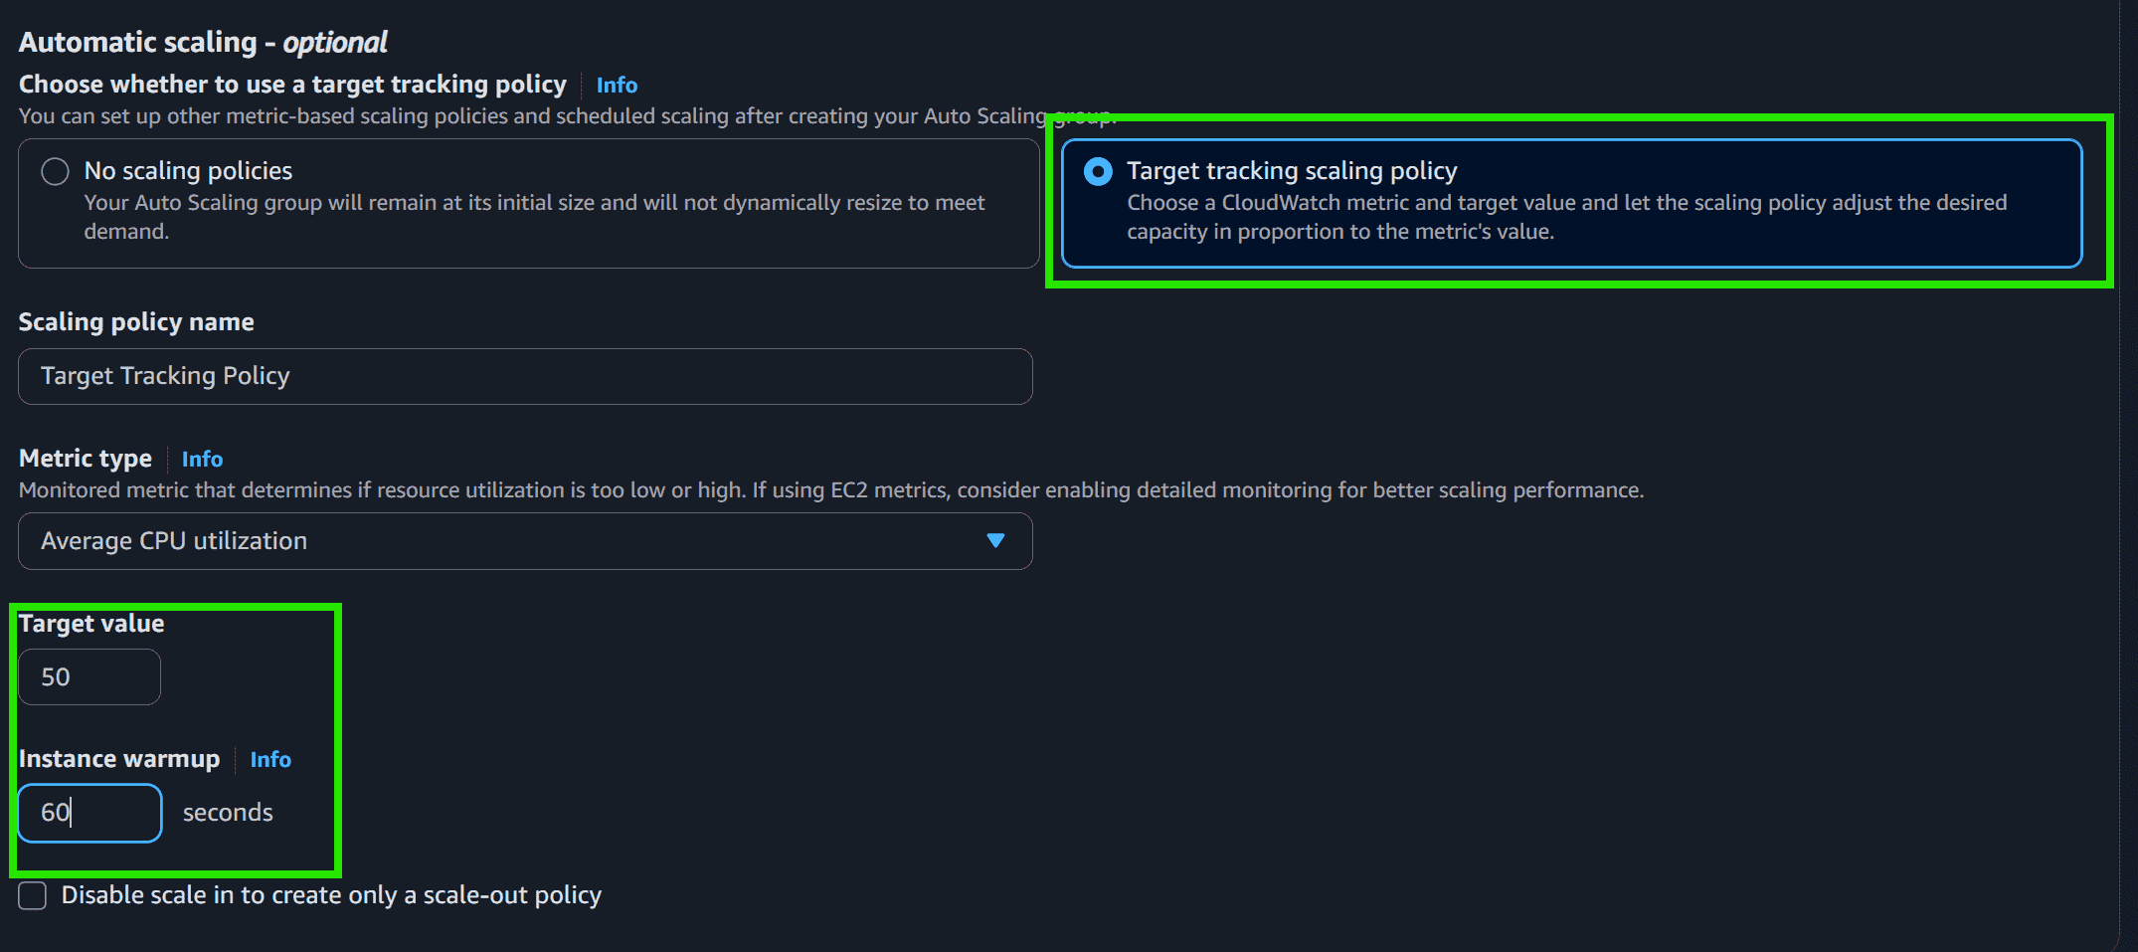
Step 8: Click on the Create Auto Scaling Group.
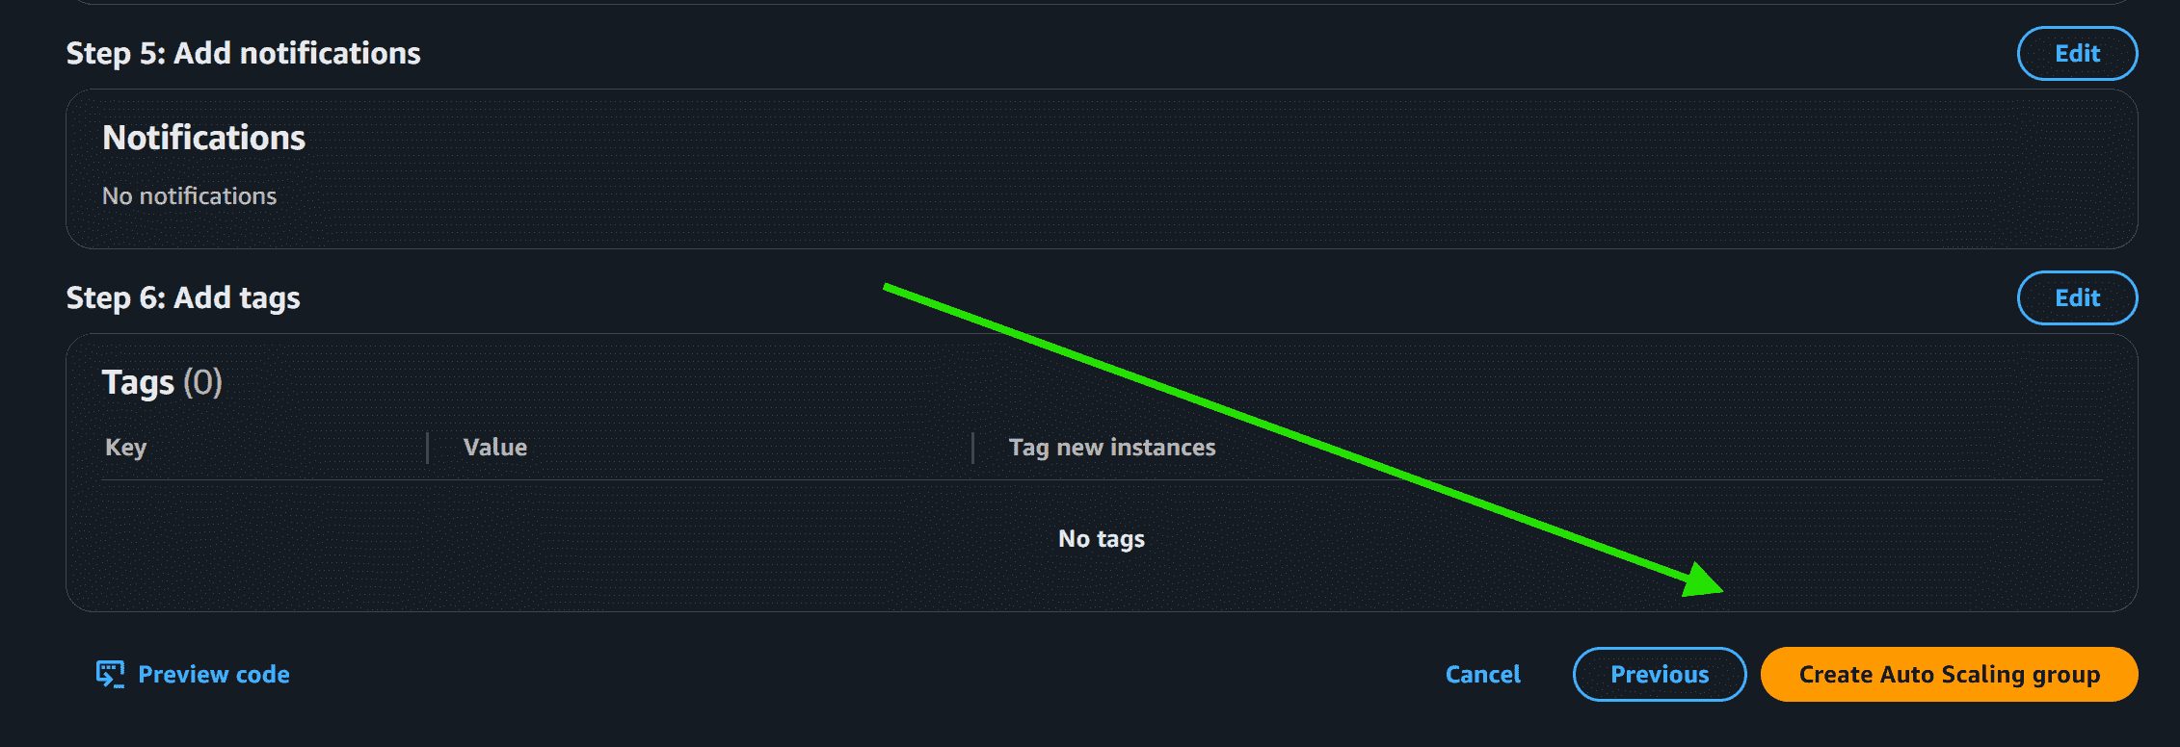
- Now you can see the Auto Scaling is creating and it is also creating the desired state of the EC2 Instance
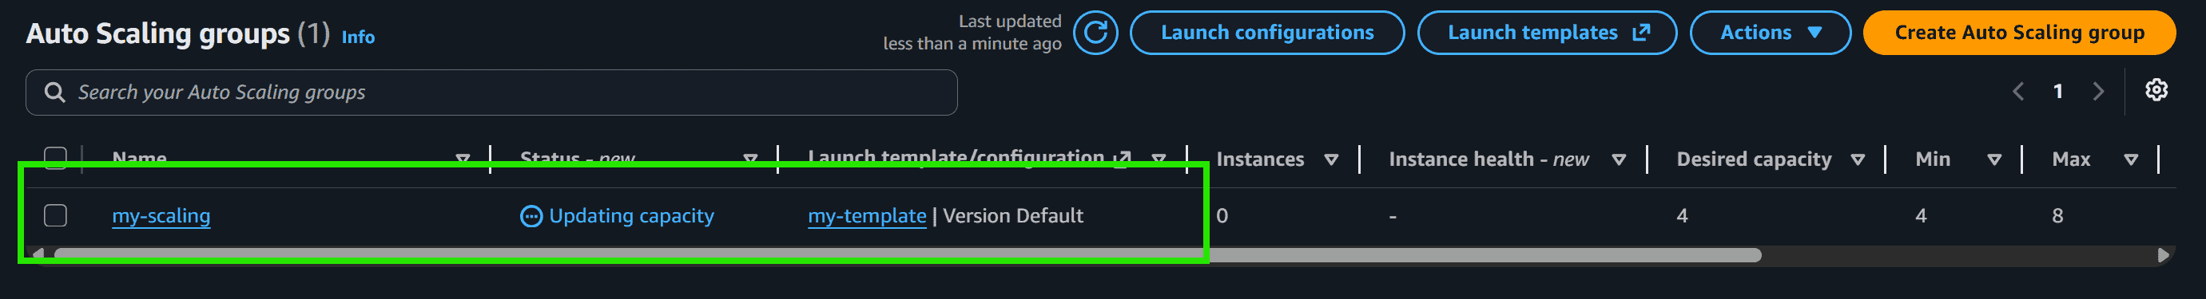
- We selected the Desired state equal to 4 and you can see the 4 Instance is Running
